Decision Log

0. Context – Why does this question exist?
Project / assignment this belongs to
StackEval Benchmark – Professional Research Project
Why this matters right now
Before running the StackEval experiment, the LLMs that will be evaluated must be selected. Without deciding which models to benchmark, it is impossible to design the experiment or begin collecting model responses for comparison.
Where this fits
StackEval Benchmark project scope – evaluation of LLMs on real Stack Overflow programming questions.

1. Research Question
Which LLM models should be selected to represent the major categories of the current LLM ecosystem when benchmarking real programming questions using the StackEval approach?

2. Current Learning Outcome (LO) Stage
☑ Analyzing
☑ Advising
☐ Designing
☐ Realizing
☐ Managing

3. What Makes a Good Decision?
Criteria for Success
• The experiment must include at least four models representing different LLM categories (frontier, competitor, open-source, and budget).
• The selected models must be widely used or well documented, so the results are meaningful and comparable with existing benchmarks.
• The number of models must remain manageable for analysis, meaning the benchmark can realistically evaluate all model responses within the project timeline.

4. Decision
The benchmark will evaluate four LLM models, each representing a different segment of the current LLM ecosystem.
Selected Models
Frontier proprietary model
GPT-4o (OpenAI)
Frontier competitor
Claude 3.5 Sonnet (Anthropic)
Open-source model
Llama 3.1 (Meta)
Budget / lightweight model
GPT-4o mini (OpenAI)

5. Reasoning Behind the Decision

Method Used
Structured Socratic reasoning and exploratory research were used to analyze the current LLM ecosystem and determine which models represent the main categories relevant to benchmarking.

Observations
The StackEval experiment aims to compare models from different segments of the LLM ecosystem, rather than evaluating only one category of model.
The ecosystem can broadly be divided into four segments:
• Frontier proprietary models with the highest capabilities
• Competing frontier models from other providers
• Open-source models widely used in research and development
• Budget or lightweight models optimized for lower cost

Evidence & Artifacts
• ChatGPT discussion used to analyze model options and reasoning process: https://chatgpt.com/share/69b7f668-b368-8002-90b6-d4634e666ecd
• Screenshot of the reasoning process included in portfolio evidence
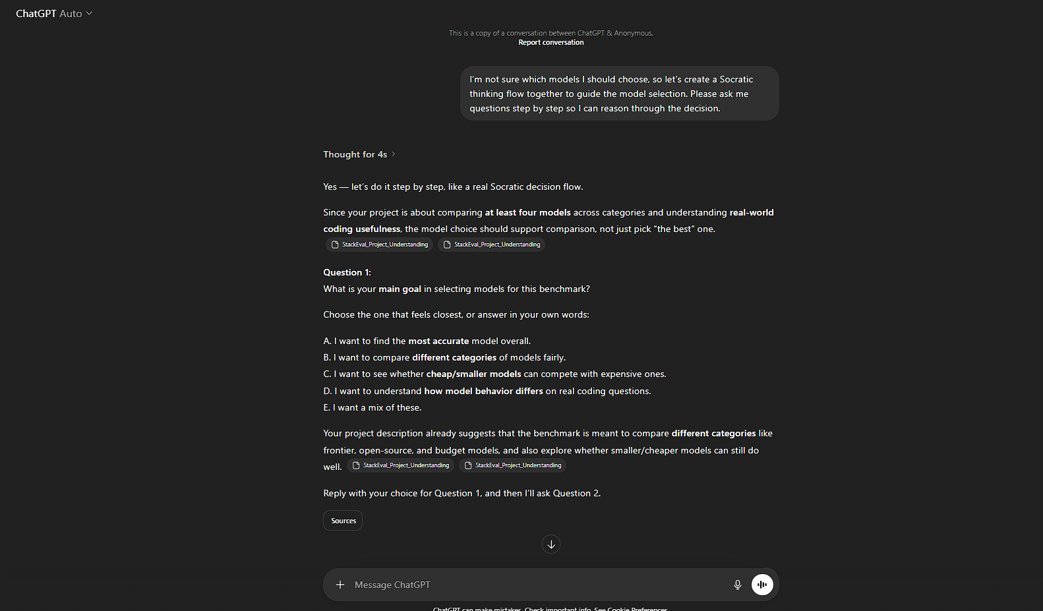

Interpretation
Selecting one model from each major category allows the experiment to compare:
• different LLM ecosystems
• open vs proprietary models
• high-capability vs cost-efficient models
while keeping the benchmark manageable and focused.

Final Decision
Four representative models from different LLM categories will be evaluated so that the benchmark remains balanced while still allowing meaningful comparisons between ecosystems and model types.

6. Evaluation of the Decision
How Well This Meets the Criteria
Criterion 1 – Representation of model categories
✅ Four models representing the required categories were selected.
Criterion 2 – Relevance and documentation
✅ The models are widely documented and commonly referenced in benchmarks.
Criterion 3 – Experiment manageability
✅ The experiment remains manageable with four models.

Assumptions
The selected models are sufficiently representative of their respective categories and provide a fair comparison between different LLM ecosystems.

Reflection
I initially assumed that the most widely used models would simply be the ones I personally interact with most frequently. However, I discovered that research benchmarks often reference specific API models and ecosystems, which differ from everyday usage.

7. What This Unlocks
Next LO Stage: Designing
The next decision will focus on how the models will be queried during the experiment, specifically whether the benchmark should use manual prompting or API-based evaluation.

What I Can Now Do
I can now design the benchmark evaluation setup, including:
• selecting Stack Overflow questions
• determining how the models will be queried during the experiment

How I Will Know This Worked
The experiment will successfully collect responses from all four models for the same programming questions, enabling a direct comparison of answer quality.

